**✅ PHASE II: Business Process Modeling (Church Management System - MIS)**

**🔹 1. Define the Scope**

Business Process: Member Registration and Event Management

Scope: We will model the process of registering new church members and managing their participation in church events. This includes collecting member information, assigning them to ministries or groups, and allowing them to sign up for events or volunteer roles.

Objectives:

Streamline member registration and data capture

Organize event participation records

Facilitate data-driven decisions for event planning and member engagement

Expected Outcomes:

A more organized, digital member database

Faster and more accurate event coordination

Enhanced decision-making for church staff

**🔹 2. Identify Key Entities**

Entity Role New Member Registers with the church, provides personal info, selects ministry Church Staff Approves registration, adds to system, manages events Database Stores member data, event participation records Event System Notifies members, tracks sign-ups and attendance MIS Dashboard Summarizes data for decision-making

**🔹 3. Swimlanes (Visual Separation)**

We’ll use 4 swimlanes in the BPMN/UML diagram:

Member

Church Staff

Database

Event System

Each lane will clearly show who is responsible for which part of the process.

**📄 BPMN Diagram And Explanation – Member Registration & Event**

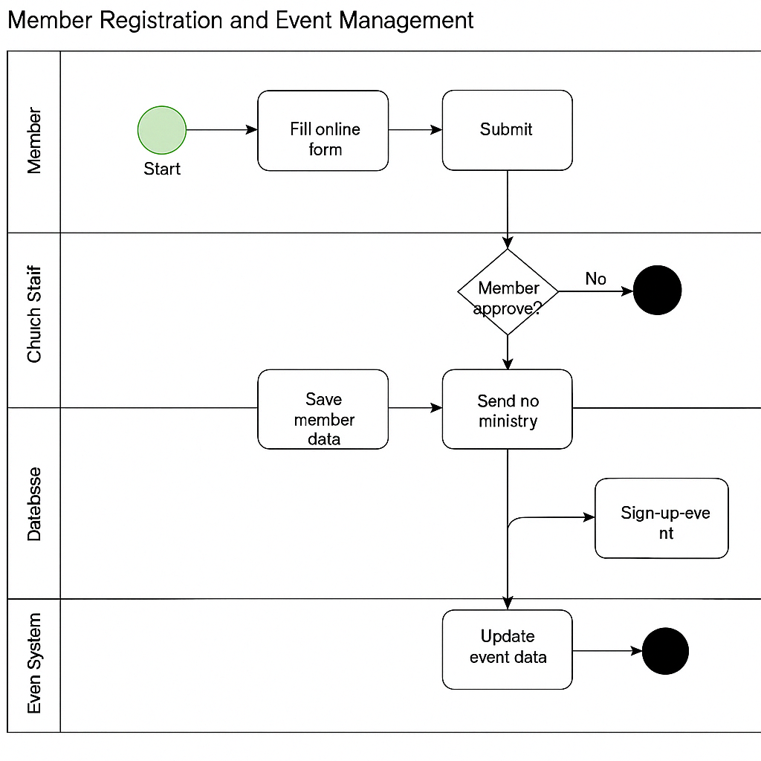

This Business Process Model and Notation (BPMN) diagram illustrates the flow of the **Member**

**Registration and Event Management** process within a Church Management System. It is

structured using **four swimlanes**: **Member**, **Church Staff**, **Database**, and **Event System**,

representing the key actors and systems involved.

The process begins with a **new member** filling out a digital registration form. Upon submission,

the **church staff** reviews the form and either approves or rejects the registration. If approved, the member's data is saved in the **church database**, and they are assigned to a relevant **ministry** or

group.

The member is then notified of upcoming events and given the option to **sign up**. The **event**

**system** checks for capacity and updates attendance records. Throughout the process, data is

stored and accessed through the **MIS**, allowing for real-time updates and accurate tracking.

This BPMN model supports MIS functions by:

• **Automating data collection** and reducing manual errors

• Providing a **centralized information flow**

• Supporting **decision-making** for staff via real-time dashboards

• Enhancing **operational efficiency** in managing people and events

By clearly visualizing how users, staff, and systems interact, this process model demonstrates

how MIS contributes to **organized, da-driven church operations**.